Картотека игр с использованием блоков Дьенеша. 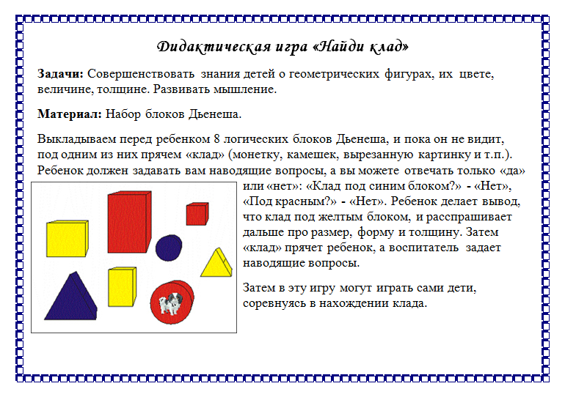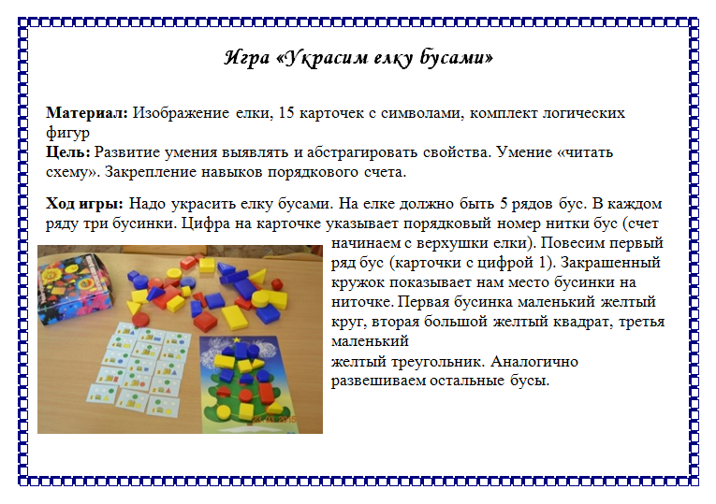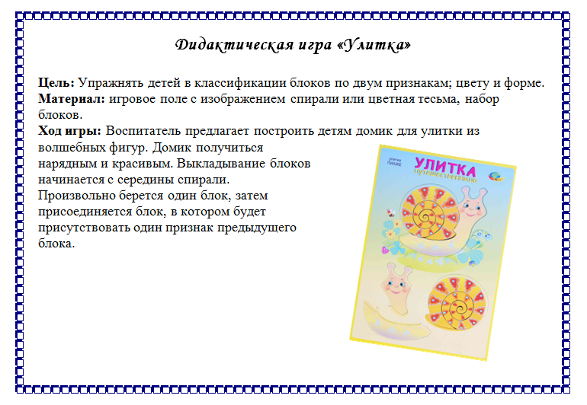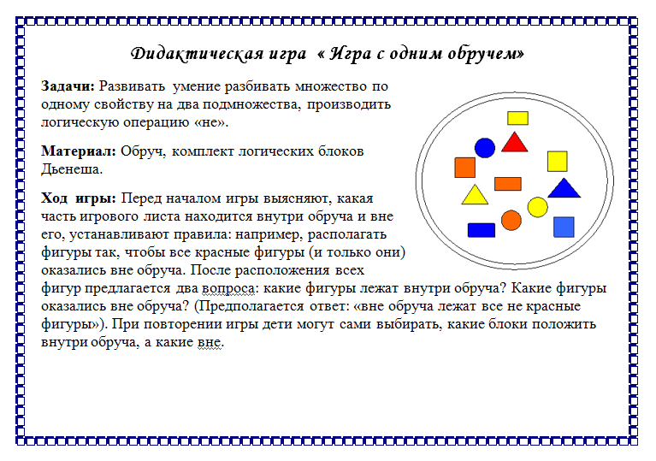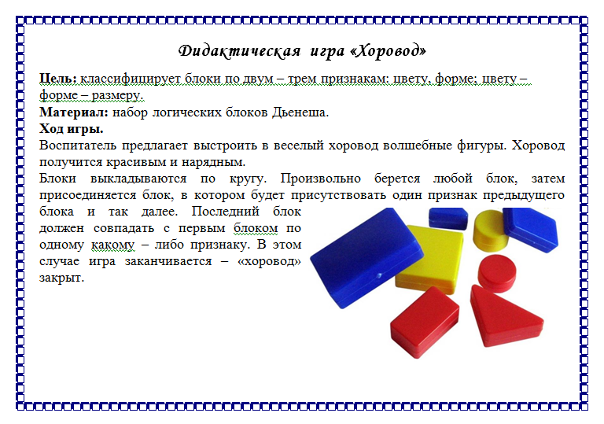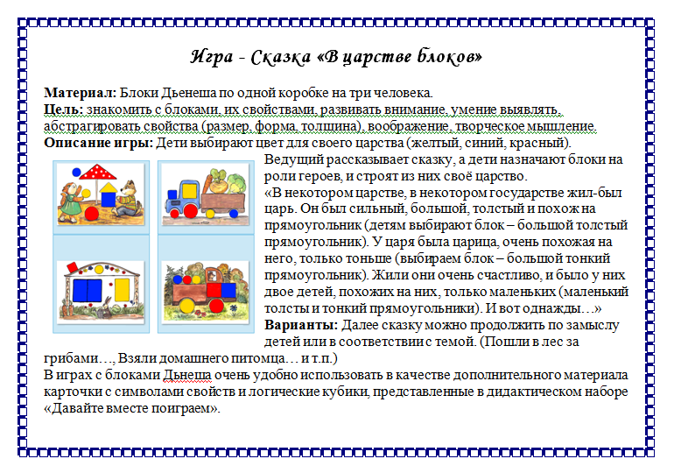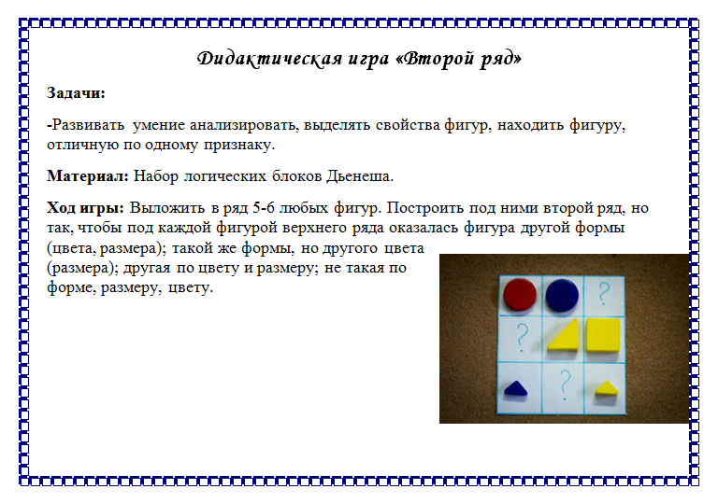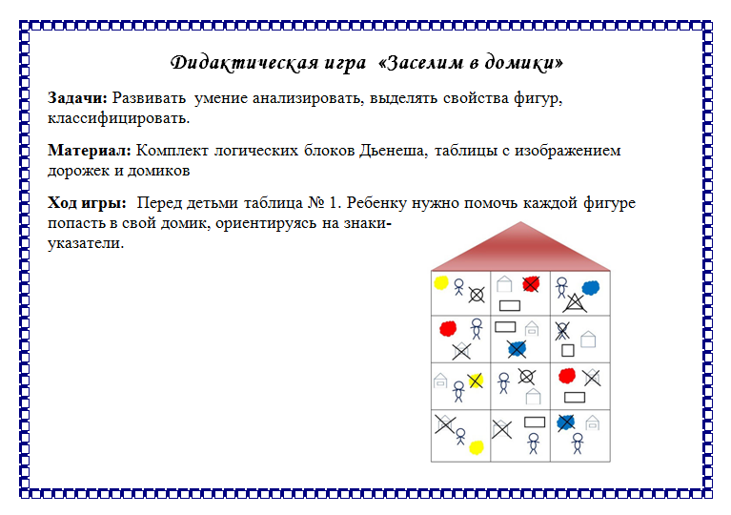[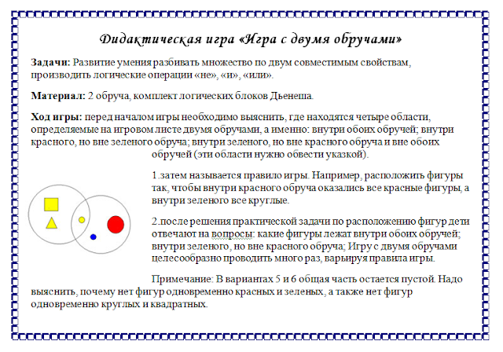](https://1.bp.blogspot.com/-KurHne3v-f4/W7SEzq9e-bI/AAAAAAAAAP8/ut9qWRsCK9EMs6cZfawNruGpWUppXUAywCLcBGAs/s1600/%D0%B0%D0%B2%D0%BC%D0%BC.PNG)[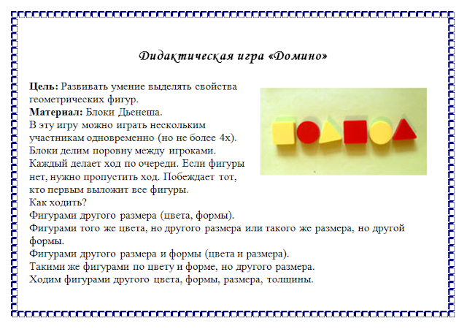](https://1.bp.blogspot.com/-ZH1h7OvgC7U/W7SEzkH9ibI/AAAAAAAAAQA/UfzeLzfUiogpryIgT-mFXD0aJKfI0bPLgCLcBGAs/s1600/%D0%B0%D0%BF%D0%B0%D0%B2%D0%BF.PNG)[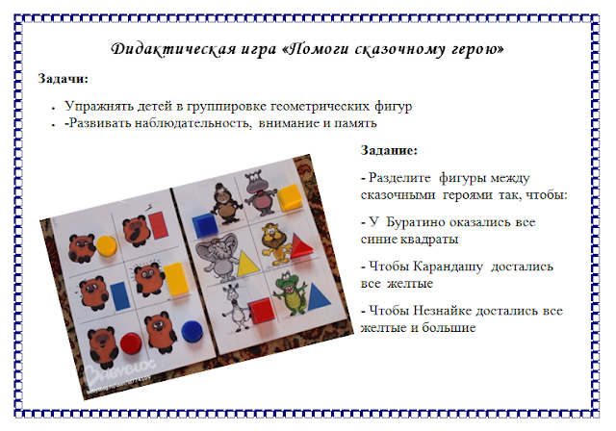](https://4.bp.blogspot.com/-YJrIMBq9M2M/W7SE087Pf_I/AAAAAAAAAQM/eDbhb5ozhkgYMhlcflNP3h8ga_dhdrMugCLcBGAs/s1600/%D0%B0%D1%83%D1%8B%D1%83%D0%B0%D1%8B.PNG)[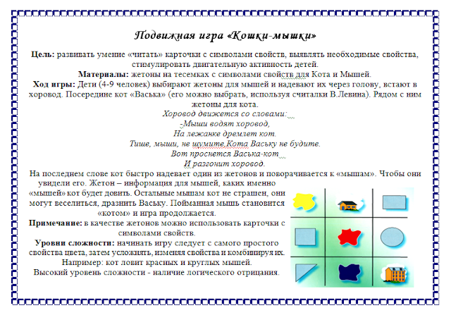](https://3.bp.blogspot.com/-0NNdRuFLUlI/W7SE1XvdgLI/AAAAAAAAAQU/NtC_FKVHep0ZJ3d7FKQ7iW46R_kuEgUygCLcBGAs/s1600/%D0%B2%D0%B0%D0%B2%D1%8B.PNG)[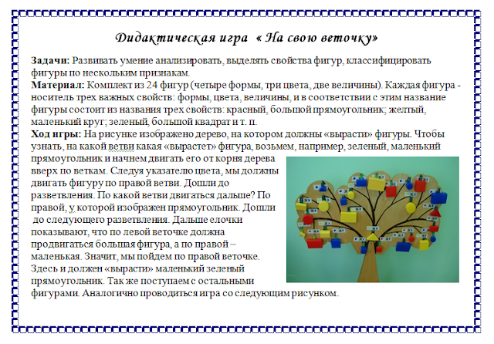](https://1.bp.blogspot.com/-xiPWbIDFkLk/W7SE1czJqDI/AAAAAAAAAQQ/O_YJaX33YgkUP0PRzCOLWtc72AFjZEGIwCLcBGAs/s1600/%D0%B2%D0%BF%D0%BC%D0%B2%D0%B0.PNG)[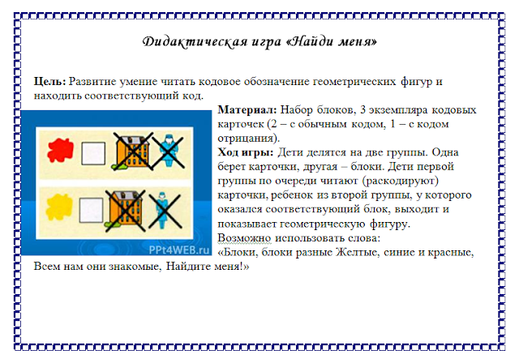](https://2.bp.blogspot.com/-QQawG0Oc5bA/W7SE1sVyeRI/AAAAAAAAAQY/H4lSX8yp8tEpuz7qQ1AqoyS7bTztCadcACLcBGAs/s1600/%D0%B8%D0%BF%D0%BF%D1%80.PNG)[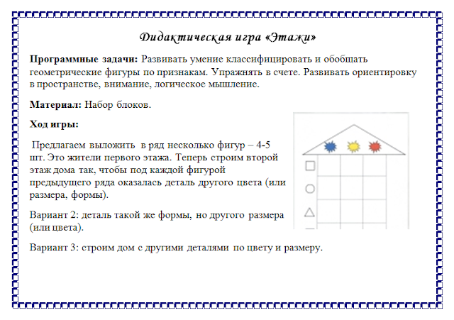](https://3.bp.blogspot.com/-OLgkdoPlI3o/W7SE3vswGaI/AAAAAAAAAQ0/Yc_sxU_K7Xc03CDjfntEL5oKdU3VjdLKgCLcBGAs/s1600/%D1%83%D1%8B%D0%BF.PNG)[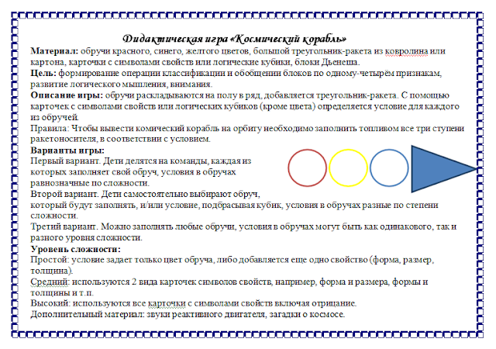](https://3.bp.blogspot.com/-JQ2KSktOeTw/W7SE1xjVO_I/AAAAAAAAAQc/cA42B1a7lUgwn0UDLhzvQAG_oBh7EJtowCLcBGAs/s1600/%D0%BA%D0%B0.PNG)