

Wh- Questions

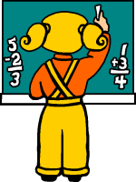
Допишите What, What time, Who, Where, How, How old, How many или When. Затем соедините с картинкой. Чтобы лучше понять какой вопрос нужно подставить, лучше для начала перевести ответ

1-___________ is she? She is a girl.

2-___________ is it? It’s five to three.

3-___________ are they? They are in the school bus.
4-___________ is it? It’s a famous museum.
5-___________ is Christmas? It’s on 25th December.

6-___________ is he? He is nine years old.
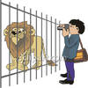
7-___________ are they? They are best friends.
8-___________ is he? He is a judge.
9-___________ is she? She is at school.

10-__________ is he? He is an actor.
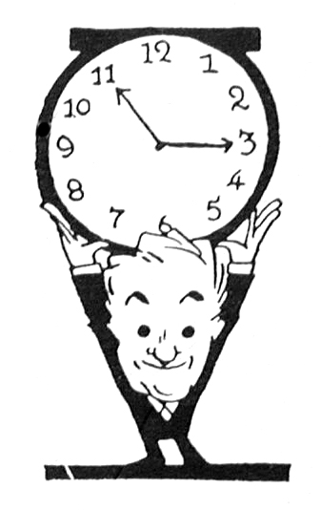
11-__________ are you going? I’m going to the cinema.
12-__________ are you? I’m sick.
13-__________ people are there in the picture? Nine.

14-__________ is he doing? He is writing.

15-__________ is she doing? She is painting.

16-__________ is he? He is at the zoo.

17-__________ is it? It’s a lamp.





