
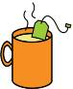
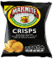
DRINKS
MEAT
SWEETS / DESSERTS
FRUIT
VEGETABLES
OTHER

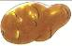

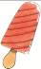

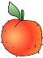

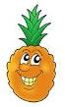

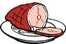

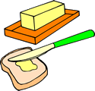
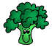
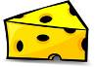

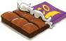

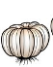
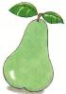

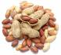


1 chocolate2 crisps 3 cake
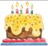
4 cookies 5 ice cream 6 potato
7 milk 8 pizza 9 tea 10 steak
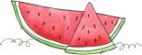
11 pear 12 strawberry13 carrot
14 garlic 15 pineapple 16 chips 17 broccoli
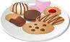
18 wine 19 cheese 20 water 21 peach
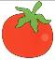
22 coffee 23 butter 24 pretzel 25 tomato

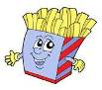
26 peanut 27 egg 28 ham 29 watermelon
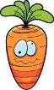
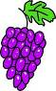

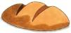
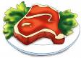

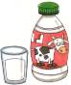
30 bread 31 grapes

Перевести и рассортировать

