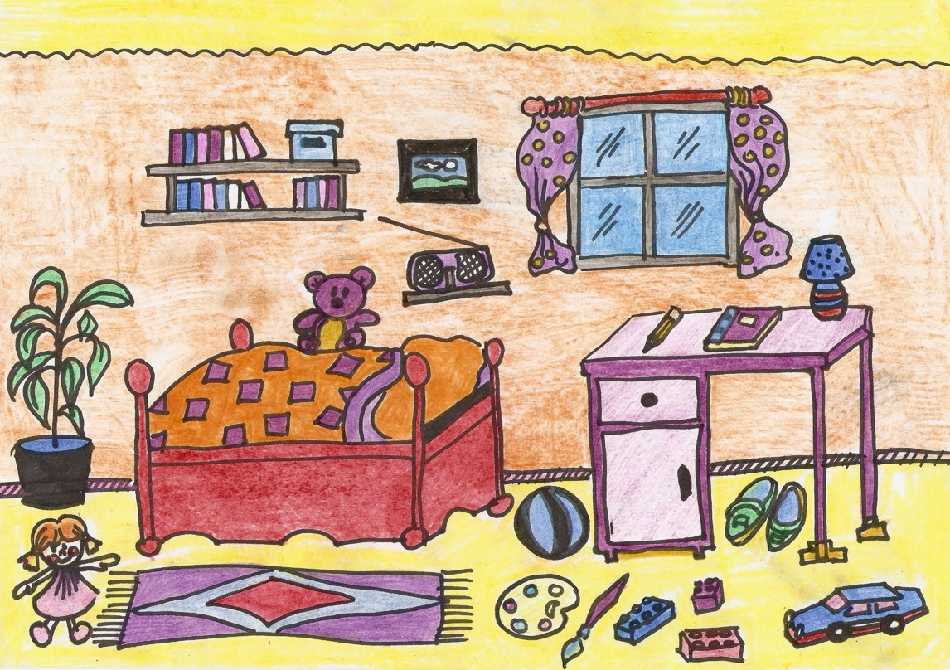
Предлоги места

In on between under in front of
Behind on the right of on the left of

Complete the sentences with the right preposition.

- The radio is ......................... the shelf. 16 The pencil, the book and the lamp
- The ball is ........................... the desk and the bed. are .......................... the desk.
- The shoes are ........................ the desk. 17 The desk is ..................... the bedroom.
- The plant is ............................. the pot. 18 The shelves are ...................... the wall.
- The rug is ................................. the bed. 19 The doll is ................................ the rug.
- The lamp is ............................. the desk. 20 The window is ...................................
- The book is ......................... the pencil and the lamp. the picture.

- The lamp is ................................... the book.
- The pencil is ................................. the book.
- The picture is ............................. the wall.
- The rug is ........................... the doll and the palette.
- The paintbrush is .............................. the palette.
- The palette is ................................. the ball.
- The teddy bear is ......................... the bed.
- The books are ............................. the shelves.

Перевести предлоги и вставить подходящие по смыслу в предложения, предварительно
Их необходимо также перевести. Задание на 2 урока

