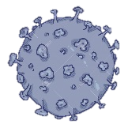

**CORONAVIRUS**

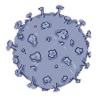

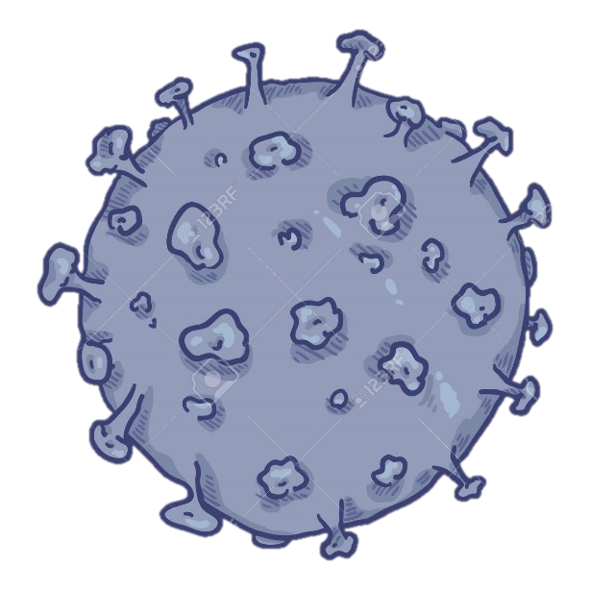Coronavirus is a newly discovered virus. It causes a disease called Covid-19. In some parts of the world, it has made lots of people sick. Corona is a Latin for crown, because under the microscope, these viruses look like a crown with spikes ending in little blobs.

A lot of symptoms are similar to the flu. You may have dry and itchy cough, fever, lots of sneezing and even hard to breathe. Most of people who has gotten sick with this coronavirus have had a mild case. It means you will not feel the disease. But, for people who are much older or who already have health problems are more likely to get sicker with coronavirus.

If anyone gets sick and feels like they may have coronavirus, they can immediately call their doctors and get help. If there is something we are not sure about the information, confused or worried about, don’t be afraid to ask someone we trust.

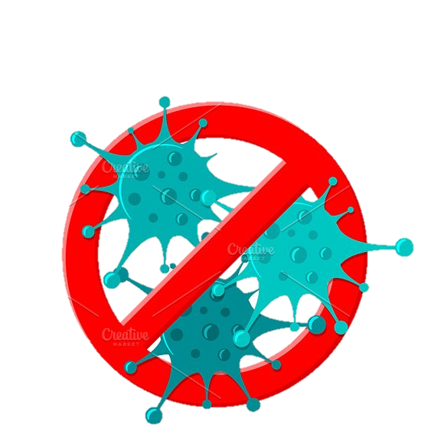Here are some things you can do to protect yourself, family and friends from getting sick: 1) wash your hands often using soap and water. 2) Sneeze into your elbows. It is believed that coronavirus spread through little liquid from our lungs. If you sneeze into your elbows, you can prevent germs for going far into the air. 3) Avoid touching your face. Don’t pick your nose. Don’t touch your mouth. Don’t rub your eyes. They are the places where the virus enter our bodies.

Remember that this kind of virus can affect anybody. It doesn’t matter where you come from or what country you are from. Don’t forget, there are a lot of helpers out there who are working to protect us from the virus. We can take a part by keeping our health and stay at home to stop the virus spread to others.

*Edited from https://www.npr.org/sections/goatsandsoda/2020/02/28/809580453/just-for-kids-a-comic-exploring-the-new-coronavirus*

|  |
| --- |
| **Say TRUE or FALSE**   1. Coronavirus causes a common flu. (............) 2. Under a microscope, the virus is look like a crown. (............) 3. The symptoms of disease by Coronavirus are different with the flu. (............) 4. Older people will get more illness with coronavirus. (............) 5. We should call firefighter to get help from coronavirus. (............) 6. We should not touching our faces to avoid the virus. (............) 7. It is enough to wash our hands only by water. (............) 8. Staying at home is our part to stop the virus. (............) 9. The virus only affect people in Asia. (............) |

Текст перевести, после текста выбрать true (правда) или false (неправда)