HOW TO PREVENT CORONAVIRUS

|  |  |  |  |  |  |  |  |  |  |  |  |  |  |  |  |  |  |  |  |  |  |
| --- | --- | --- | --- | --- | --- | --- | --- | --- | --- | --- | --- | --- | --- | --- | --- | --- | --- | --- | --- | --- | --- |
| A | D | I | F | F | I | C | U | L | T | Y | B | R | E | A | T | H | I | N | G | U | E |
| O | R | O | G | R | R | S | P | U | I | F | R | A | N | S | O | D | N | L | R | K | D |
| C | T | I | K | N | A | I | C | O | T | I | L | E | I | T | R | E | S | E | L | S | A |
| I | A | I | O | L | C | K | M | G | N | I | Z | E | E | N | S | T | W | A | H | I | T |
| D | N | W | I | B | R | S | T | O | S | I | H | N | X | S | D | O | U | A | R | R | R |
| E | I | S | A | A | U | E | P | V | Y | K | E | P | H | E | H | N | N | E | D | P | O |
| G | E | N | O | E | L | O | G | A | T | I | R | E | K | S | D | D | V | E | S | U | A |
| H | S | A | W | D | C | H | C | G | O | O | A | T | E | R | S | E | O | A | N | O | S |
| L | N | A | E | O | E | S | T | I | E | S | T | K | Y | A | F | G | L | B | M | R | N |
| E | O | R | I | D | U | L | K | U | T | V | A | B | N | W | S | L | I | B | O | G | B |
| N | L | O | R | I | S | I | I | K | O | T | E | I | H | E | L | E | T | T | O | I | R |
| Y | A | S | D | I | S | O | D | R | D | M | T | W | T | N | U | L | H | R | N | W | E |
| H | N | E | G | S | I | E | C | O | T | I | H | E | A | T | R | I | S | D | E | S | O |
| A | N | R | E | U | T | N | Y | R | Z | L | G | E | A | A | D | S | N | K | R | N | C |
| P | P | S | M | H | H | P | E | E | H | H | I | P | A | H | E | H | A | S | H | C | E |
| E | Y | N | M | E | C | T | R | V | E | G | N | I | H | G | U | O | C | E | D | P | R |

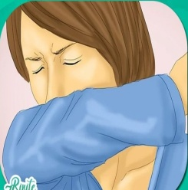

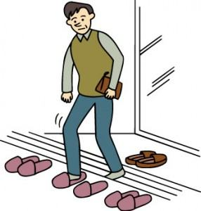

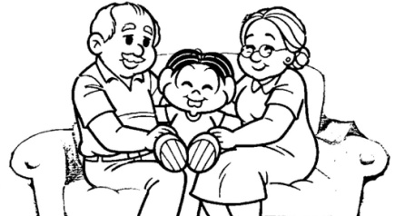

1) FREQUENTELY **WASH** YOUR HANDS WITH **SOAP**

2) WHEN **SNEEZING** COVER YOUR NOSE WITH **FLEXED ELBOW**

3) WHEN **COUGHING** COVER YOUR MOUTH WITH A **TISSUE**

4)ALWAYS USE alcohol based **hand sanitizer**

5)REGULARLY **TAKE SHOWER**

6) AVOID TOUCHING YOUR **EYES**

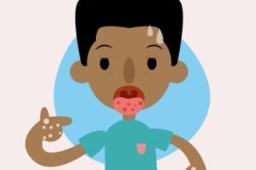7) AVOID TOUCHING YOUR **MOUTH**

8) WHENEVER IT IS POSSIBLE TAKE OUT THE **SHOES** THAT YOU WERE IN THE STREET

9) avoid contact with **elderly** people because they are in the **group risk**

10) always do the **laundry**

11) avoid **KISSES** BETWEEN EACH OTHER

12) AVOID **HUGS** BETWEEN EACK OTHER

13) AVOID TOUCHING YOUR **NOSE**

14)IF YOU HAVE **FEVER**, COUGH AND **DIFFICULTY BREATHING** SEEK MEDICAL CARE EARLY

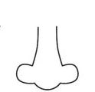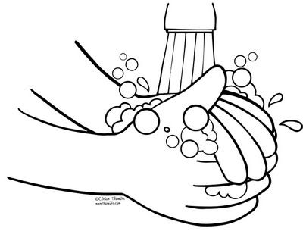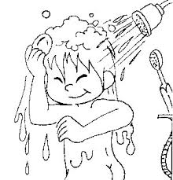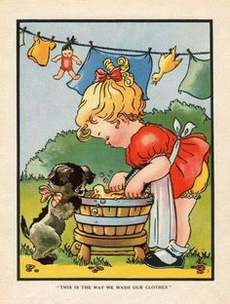

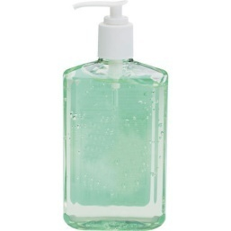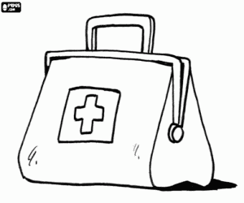

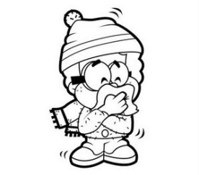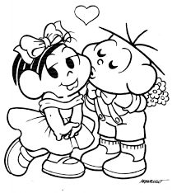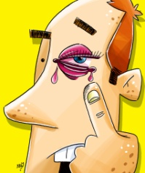

Вам необходимо перевести предложения, выделенные слова в предложениях найти в сканворде, и поставить в кружочках номера подходящих к данной картинке предложений.