Задание: Последнюю табличку заполнить самостоятельно о себе



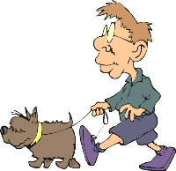




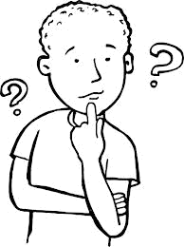
job: pupil
morning:
gets up – 6:50
goes to the bathroom
puts on his clothes
has breakfast
goes to school by bus
has seven lessons a day
afternoon:
has lunch at school (packed)
goes home – 3:45
relaxes for 25 minutes
does his homework - 4:15-5:15
goes to the sports centre (plays football)
evening:
has dinner – 7:00
watches TV
cleans his shoes
brushes his teeth
goes to bed – 9:30

Jamie
job: shop assistant
morning:
gets up – 6:00
feeds her cat
makes her breakfast
brushes teeth
tidies her room
has breakfast
leaves to work – 8:15
afternoon:
finishes work – 5:00
goes shopping
has a light dinner at a café
goes to her aerobics lesson
evening:
arrives home – 8:00
calls her friends
has a shower
watches TV
goes to bed – 10:10

Victoria
job: pupil
morning:
gets up – 7:10
has a shower
gets dressed
has breakfast
makes her bed
her father drives her to school
has six lessons a day
afternoon:
has lunch at school canteen
goes home – 3:30
does her homework - 4:00-5:30
helps her mother with the cooking
evening:
has dinner – 6:30
tidies her room
brushes her teeth
reads a book
goes to sleep – 8:30

Melanie
job: security guard
morning:
arrives home – 7:00
has breakfast
has a shower
goes to sleep
afternoon:
has lunch – 1:50
washes up
reads the newspaper
does his job around the house
helps his wife with the housework
takes the dog for a walk
evening:
has dinner – 7:15
has a shower
goes to work by car
works all night

Brian
job: retired
morning:
gets up – 5:30
washes her face and teeth
gets dressed
makes breakfast
cleans the house
cooks lunch
afternoon:
looks after her grandchildren
prepares dinner for her daughter’s family
knits
listens to the radio
evening:
does the laundry
irons the clothes
has dinner
reads magazines
has a shower
goes to sleep – 9:15

Anna
job: student
morning:
gets up – 7:30
brushes teeth
washes his face
makes his breakfast
has breakfast
puts on his clothes
leaves to university – 8:45
afternoon:
has lunch – 2:00
finishes his lessons – 6:00
plays basketball with his friends for an hour
evening:
arrives home – 7:30
has dinner
tidies the flat
reads a lot for his exams
has a bath
goes to bed – 11:20

Mark
job: student
morning:
gets up – 5:00
puts on her clothes
goes cycling (15 km every morning)
has a shower
has breakfast
goes to university – 7:45
afternoon:
has lunch in the university canteen
finishes her lessons – 4:00
meets her friends
arrives home – 6:00
makes dinner
evening:
studies
meets her boyfriend
has a shower
goes to sleep – 10:15

Jessica
job: programmer
morning:
gets up – 9:30
has breakfast
naps a little
starts working at home – 11:00
afternoon:
has lunch – 3:15
gets dressed
works on his computer
has some snacks
evening:
calls his mother
orders a pizza
has dinner
chats with his friends
has a shower
goes to sleep – 2:30

Paul
job:
morning:
getting up?
having a wash?
breakfast?
going to school/work?
afternoon:
lunch?
going home?
doing your homework?
sports?
meetings?
housework?
evening:
helping somebody?
dinner?
reading?
watching TV?
playing?
going to bed?

You

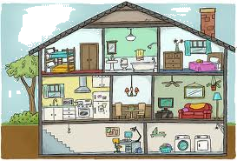

location: Birmingham
address: 91 Kingsway Road
floors: 2
garden: yes (big)
basement: yes (study, laundry room)
downstairs: living room, kitchen, dining room
upstairs: 2 bedrooms, bathroom
in the bathroom: bathtub, shower, washbasin, toilet
Diana

