Задание: Вам необходимо найти в сканворде всех животных, что нарисованы ниже.
Word Search Animals
e | l | e | p | h | a | n | t | r | c | g | e | g | c
d | o | n | k | e | y | w | m | a | v | i | l | g | v
x | x | s | z | p | q | w | o | b | s | r | i | x | v
s | v | n | g | e | z | r | n | b | c | a | d | e | r
s | c | n | b | e | a | r | k | i | s | f | c | s | r
d | c | c | g | h | f | e | e | t | g | f | o | r | e
d | c | n | g | s | o | s | y | s | o | e | r | o | g
p | a | n | d | a | x | v | s | g | d | d | c | h | i
l | i | o | n | p | i | g | a | a | i | i | d | d | t

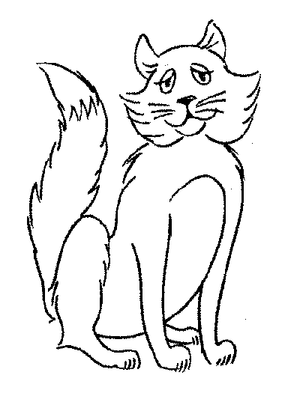 | 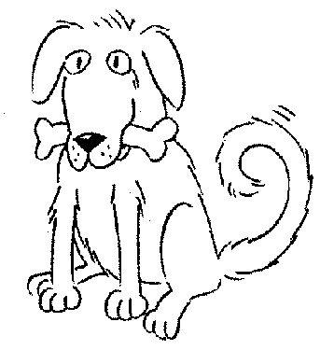 | 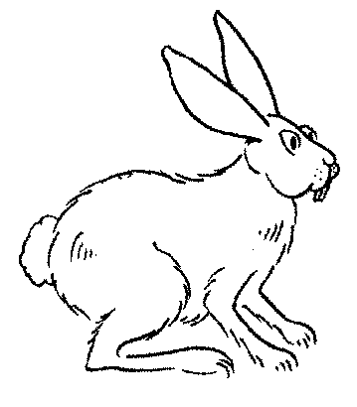 | 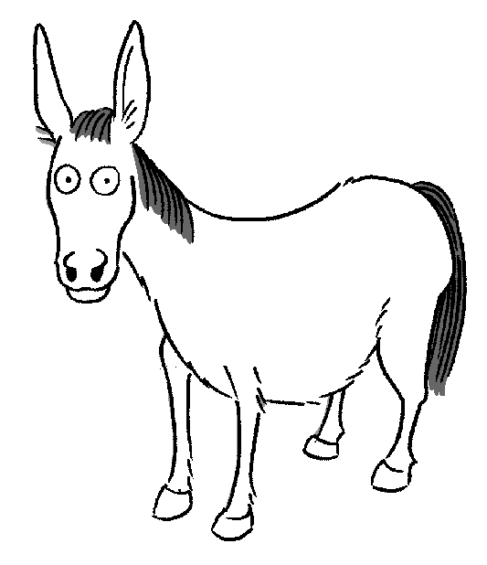 | 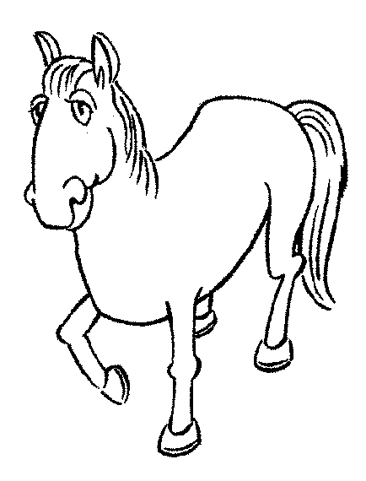
fox | dog | rabbit | donkey | horse
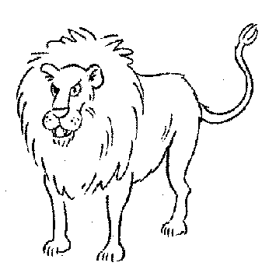 | 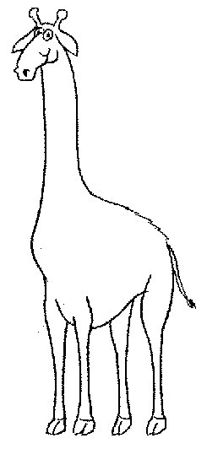 | 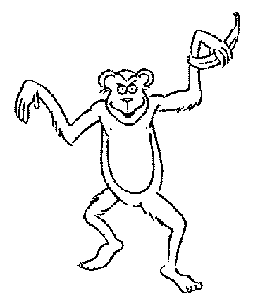 | 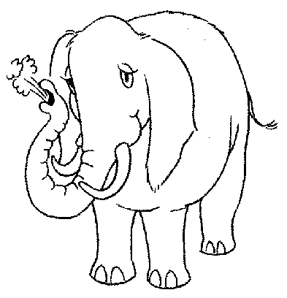 | 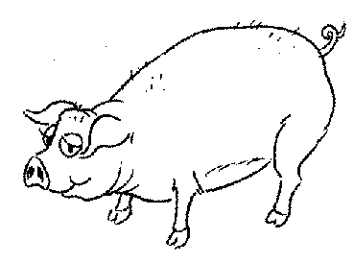
lion | giraffe | monkey | elephant | pig
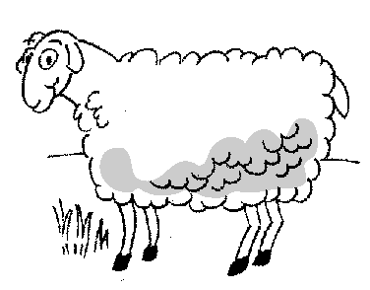 | 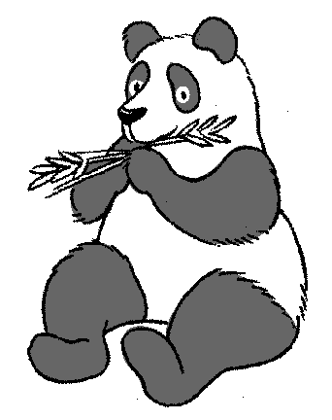 | 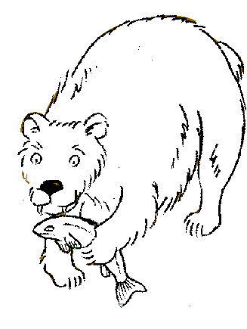 | 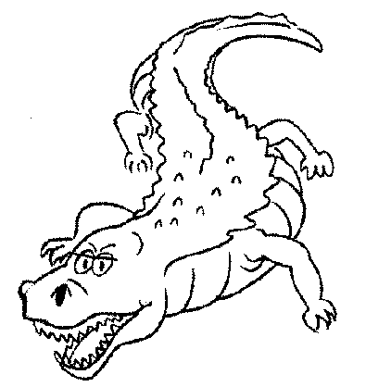 | 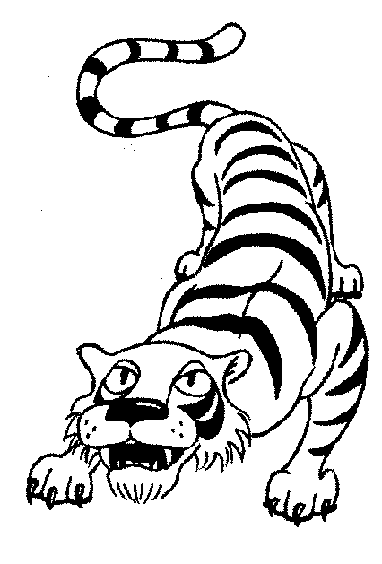
sheep | panda | bear | crocodile | tiger

