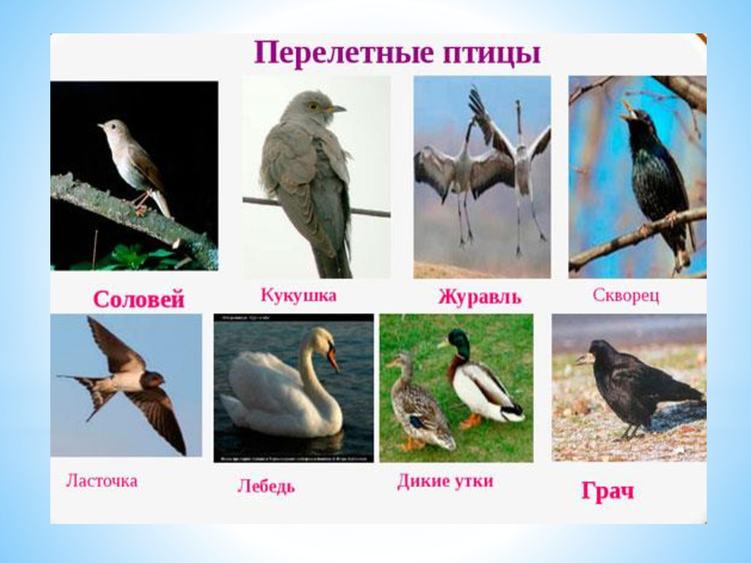

[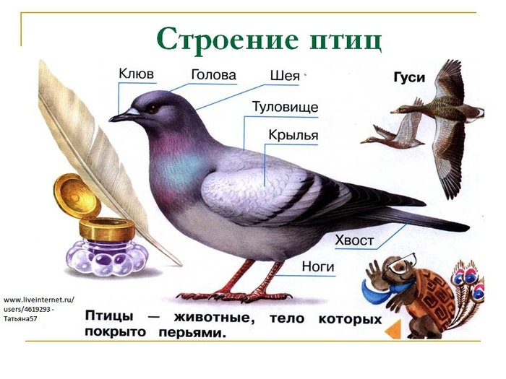](https://img1.liveinternet.ru/images/attach/c/5/85/869/85869183_large_0010010Stroenieptits.jpg)

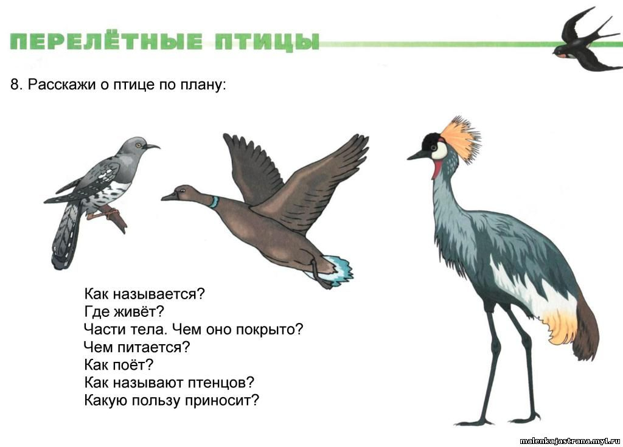

[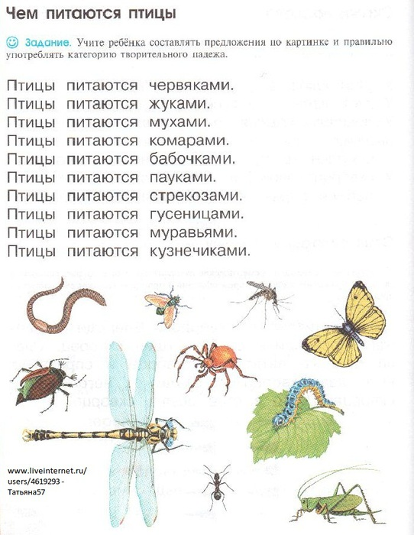](https://img0.liveinternet.ru/images/attach/c/5/85/869/85869362_large_Risunok.jpg)