муниципальное казенное общеобразовательное учреждение

средняя общеобразовательная школа № 2 г. Макарьева

Макарьевского муниципального района Костромской области

**Задания для развития функциональной грамотности**

**на уроках английского языка**

**(на базе сплошных и несплошных текстов)**

Машкова Р.Е.,

учитель английского языка

МКОУ средней школы №2 г. Макарьева

**Задание 1. Текст «The State Hermitage Museum» 6 класс**

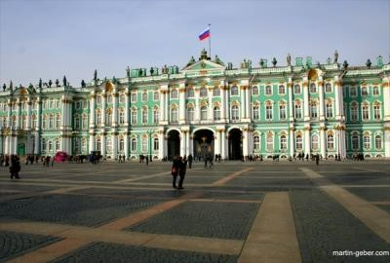

*Текст*: The State Hermitage Museum is located in St. Petersburg – the cultural capital of Russia. It is one of the largest museums in the world.

The museum was founded in 1764 by Catherine the Great and has been open to the public since 1852. Today, the Hermitage is a complex museum. Its main exhibition is located in five buildings situated in the center of St. Petersburg along the Neva river.

The main building of the complex is the Winter Palace. The building of the present (fifth) Winter Palace was built in 1754-1762 by the architect Francesco Bartolomeo Rastrelli. The building is in the style of a magnificent Elizabethan Baroque with Rococo elements.

The first thing that catches one’s eye is the splendor and solemnity of the outer shape of the Winter Palace. Along the perimeter of the building above the cornice there are sculptures and vases, which give the building a gorgeous and elegant look.

The three-storey building of the Winter Palace has four wings and a courtyard. The building’s facades face the Neva river, the Palace Square and the Admiralty. The main facade is cut with an arch of front drive.

Modern palace is made in emerald colors; columns, cornices and window frames are in white; and stucco molding and the rest decor is made in ocher. *Задания к тексту*:

1. Прочитай текст. Подчеркни понятия, которые характеризуют «the Russian Museum».
2. Составь кластер характеристик «Winter Palace».
3. Выпиши 3-4 наиболее важных, на твой взгляд, словосочетания.
4. Выбери правильный вариант ответа, согласно тексту:

1. The Winter Palace is

* 1. beautiful
  2. in the style of Baroque
  3. in the style of Rococo
  4. The State Hermitage Museum
  5. was founded in 1764
  6. was founded in 1852
  7. is very large and iconic for Russian people.
  8. Modern palace
  9. is made in emerald colours
  10. is made in white colours

с) open every day.

1. На какие вопросы ты сможешь ответить?
   1. When was the palace founded?
   2. What is the style of Winter Palace?
   3. What was the name of the architect who built the Winter Palace?
   4. How many square meters is the area of the Palace?
   5. What was the name of the ruler of Russia, who the Winter Palace was built?
   6. What portrait from the gallery of the Romanoff’s in the Hermitage does you like the most?

Добавь три своих вопроса.

1. Запиши информацию, которая показалась тебе: 1) необычной, 2) интересной, 3) полезной.

**Задание 2. Изучение ситуативных текстов 8 класс**

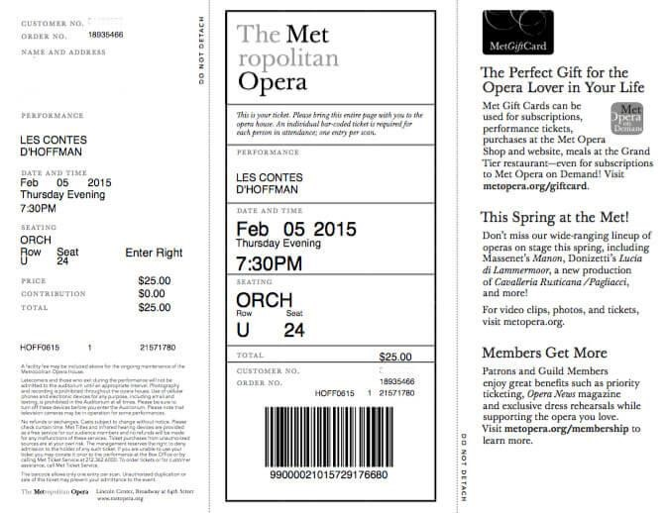

Write T(true), F (false), NS (Not stated):

1. You can visit the Metropolitan opera every day.
2. Number of tourist place – 24.
3. The performance is called «Les Contes d’Hoffman».
4. The ticket can be booked on-line.
5. This ticket was sold in March.
6. Guild Members have priority ticketing.
7. The owner of this ticket visited New York in 2017.
8. The visitor was in Metropolitan opera in the morning.
9. More than one person could use this ticket.

**Задание 3.**

**THINGS THAT GO BUMP IN THE NIGHT**

|  |
| --- |
| ***Are you interested in ghosts? Do you need any advice about where to find them? Here's some information about ghosts in Britain. We're not promising you'll find any ghostly activities, but if you have time, you might like to carry out your own invertigation!***    A Glasgow  The Theatre Royal is haunted by the spirit of a cleaning lady, Nora.  B Preston  The 13th-century Chingle Hall, three miles north west of Preston, is said to be England's most haunted house.  C Manchester  The Grey Man of the Great Western Hotel wears a grey sweater and is apparently most often seen in the cellars.  D Birmingham  The beautiful Jacobean mansion of Aston Hall has a heap of ghosts due to a murderous 17 th-century owner. With any luck, you'll see a housekeeper in a green dress with a white collar, a grey lady and a servant who died in the attic.  E Gloucester  People say the courteous spirits at the Bishop's House help visitors on with their coats.  F Swansea  The Grand Theatre has a White Lady who leaves a scent of violets. She is thought to be the spirit of a young actress who left the theatre to board the ill-fated Titanic.  G Cardiff  Cardiff Castle has a giant ghost that is 3 metres tall.  H Bristol  Leigh Woods, by Clifton Gorge, is said to be haunted by Clifton Suspension Bridge builder, Isambard Kingdom Brunel.  I Torquay  Torre Abbey has the ghost of a brightly-lit coach and horses, driving a smilin Lady Cary down the avenue.  J Brighton  Brighton's seaside is home to the spectral 10th-century galley, the Nicolas, which sank with all hands (and pilgrim passengers) returning from Constantinople.  K Eastbourne  The Devonshire Park Theatre is haunted by a vialonist in evening dress.  L Balcombe Tunnel  This Tunnel is haunted by four soldiers killed there during the First World War.  M York  The Treasurer's House is haunted by Roman soldiers  N Edinburgh  A demonic drummer has banged about the castle since the 17th century and Holyroodhouse has the majestic apparition of Mary, Queen of Scots.  O Cupar  The Royal Hotel is haunted by a hooded monk. |

1. Read the text and complete the frame:

|  |  |
| --- | --- |
| **Find words for someone:** | **Find words for a place:** |
| 1. who plays a violin | 1. where things are kept underground |
| 2. who fights in wars | 2. which is an underground passage |
| 3. who possesses something | 3. where people with a lot of money live |
| 4. who plays a loud instrument | 4. where a royal family might live |
| 5. who makes a religious journey | 5. where plays are performed |
| 6. who constructs something | 6. where religious people live |
| 7. who can be the ruler of the country | 7. at the top of the house |
| 8. who stays in your house for a short time | 8. where people often go on holiday |
| 9. who is a religious person | 9. which is covered with trees |
| 10. who works in someone's house | 10. which is wide and lined with trees or buildings |

2. Answer questions 1-12 by choosing from sections A-O of the article. Some of the sections may be used more than once:

Which section tells you that

* you have more chance of seeing a ghost here ? ____
* these ghosts are not British ____
* this ghost is religious ? ____
* this ghostly vision carries one passenger ? ____
* this ghost played a stringed instrument ?____
* this ghost wears a pleasant perfume ? ____
* this ghost is enormous ? ____
* former employees haunt these places? ____ ____
* you are treated kindly by these ghosts ? ____ _____
* this ghostly image is a ship ? _____
* you have to go underground to see this solitary ghost ? _____
* this ghost was a construction engineer ? ____
* this ghost was a monarch ? _____

3. Complete the sentences with right words:

a) The Grey Man of the Great Western Hotel wears a grey ______ and is apparently most often seen in the _______.

b) With any luck, you'll see a _________ in a green dress with a white ______, a grey lady and a servant who _____ in the attic.

c) he Grand Theatre has a White Lady who ______ a scent of violets _______.

d) The Devonshire ______ Theatre is haunted by a ________ in evening dress.

e) The Treasurer's House is _______ by Roman __________.

f) A demonic _________ has banged about _________ since the 17th century and Holyroodhouse has the majestic ________ of Mary, Queen of Scots.

g) The Royal Hotel is _________ by a hooded ________.

**Задание 4 на основе несплошного текста**

**For a school project, Mary carried out a study. Below is a bar chart that illustrates the results of her survey.**

**Analyze the information and answer the questions below.**

The study was conducted in a London school in 2018

Children surveyed:

* 100 boys (age – from 10-14)
* 100 girls (age – from 10-14)

Total: 200 children

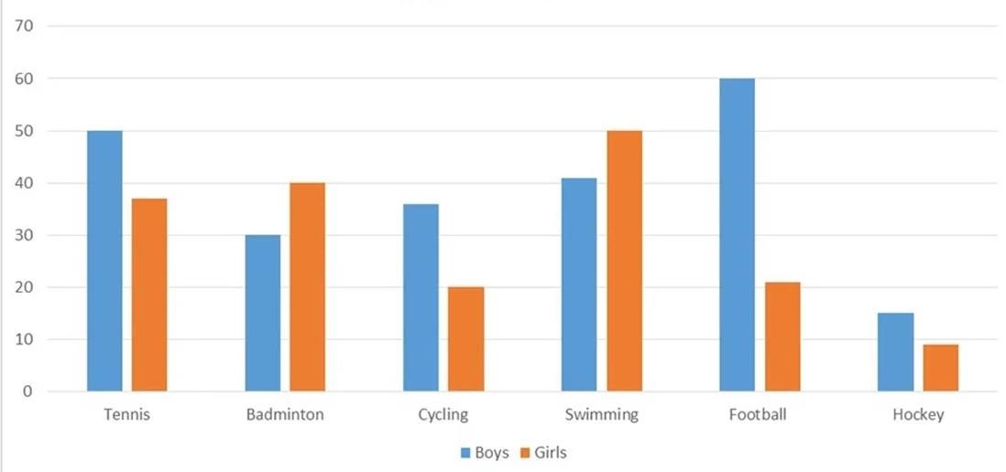

**1. What does the bar chart show?**

1. the number of boys and girls playing sport in 2018
2. which kinds of sports were the most popular among the children in a London school in 2018
3. why some kinds of sports were more popular than others among children in a London school in 2018
4. **What was the most popular kind of sport among the children in London in 2018?** 
   1. badminton b) tennis c) football d) cannot determine

1. **Which of these kinds of sports did children like the least?** 
   1. cycling b) hockey c) badminton d) tennis

1. **What can you deduce from the total numbers given?** 
   1. not all students answered the questions
   2. boys do not like cycling as well as girls do
   3. some students played more than one kind of sport
   4. some students didn’t play any sport

1. In her project paper, Mary wrote: “The objective of the study is to learn which kinds of sports were the most popular among the girls in a London school in 2018.” **Do her findings meet the objective?**
2. Her findings include some unnecessary information.
3. Her findings perfectly meet the objective.
4. Her findings do not meet the objective at all.

**6. Choose the best diagram (draw a line) to illustrate the following conclusion:**

***«Football is the most popular kind of sport among boys, while girls prefer swimming».***

**(A)** **(B) (C)**

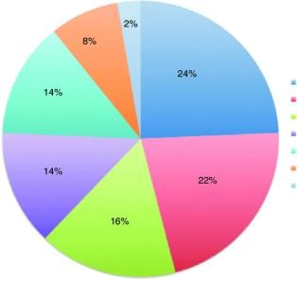 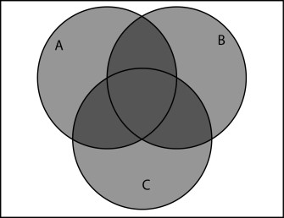

0

2

4

6

4

3

2

1

Источник: [https://www.bing.com/images/results.aspx?q=http://tehetham.com/making-columngraph-using-excel-youtube.html](https://www.bing.com/images/results.aspx?q=http://tehetham.com/making-column-graph-using-excel-youtube.html)

Ключи: 1-b, 2-d, 3-b, 4-c, 5-a, 6- A

|  |  |
| --- | --- |
| Возможные затруднения, которые будут испытывать учащиеся | Пути преодоления |
| Лексические: |  |
| a bar chart among  the objective determine  а survey conclusion  to deduce | Языковая догадка/ перевод |
| Грамматические |  |
| was conducted | Снятие трудности с помощью перевода |
| Навык чтения диаграмм | Знакомство с типами диаграмм заранее/ отсыл к прежнему опыту работы с диаграммами на уроках математики |