Приложение №

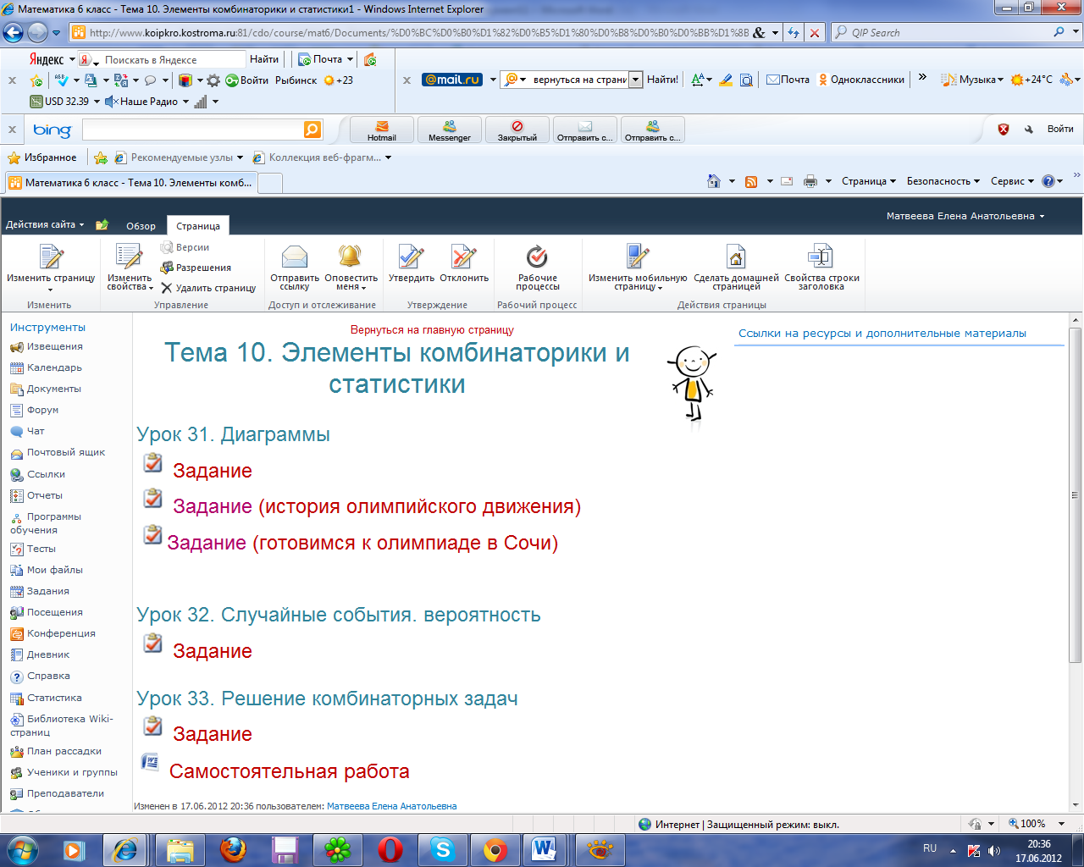

[http://www.koipkro.kostroma.ru:81/cdo/course/mat6/Documents/%D0%BC%D0%B0%D1%82%D0%B5%D1%80%D0%B8%D0%B0%D0%BB%D1%8B%20%D0%BA%D1%83%D1%80%D1%81%D0%B0/%D0%A2%D0%B5%D0%BC%D0%B0%2010.%20%D0%AD%D0%BB%D0%B5%D0%BC%D0%B5%D0%BD%D1%82%D1%8B%20%D0%BA%D0%BE%D0%BC%D0%B1%D0%B8%D0%BD%D0%B0%D1%82%D0%BE%D1%80%D0%B8%D0%BA%D0%B8%20%D0%B8%20%D1%81%D1%82%D0%B0%D1%82%D0%B8%D1%81%D1%82%D0%B8%D0%BA%D0%B8/%D0%97%D0%B0%D0%B4%D0%B0%D0%BD%D0%B8%D1%8F/%D0%BE%D0%BB%D0%B8%D0%BC%D0%BF%D0%B8%D0%B9%D1%81%D0%BA%D0%BE%D0%B5%202.aspx](http://www.koipkro.kostroma.ru:81/cdo/course/mat6/Documents/%D0%BC%D0%B0%D1%82%D0%B5%D1%80%D0%B8%D0%B0%D0%BB%D1%8B%20%D0%BA%D1%83%D1%80%D1%81%D0%B0/%D0%A2%D0%B5%D0%BC%D0%B0%2010.%20%D0%AD%D0%BB%D0%B5%D0%BC%D0%B5%D0%BD%D1%82%D1%8B%20%D0%BA%D0%BE%D0%BC%D0%B1%D0%B8%25D)

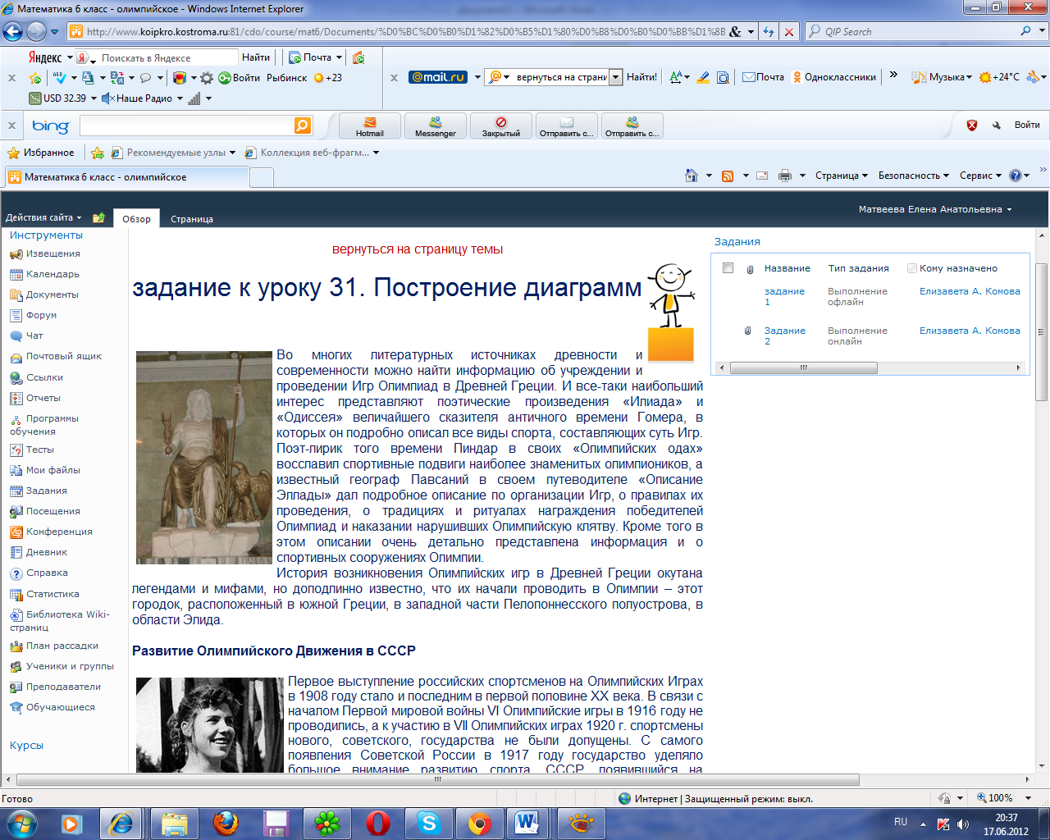

[http://www.koipkro.kostroma.ru:81/cdo/course/mat6/Documents/%D0%BC%D0%B0%D1%82%D0%B5%D1%80%D0%B8%D0%B0%D0%BB%D1%8B%20%D0%BA%D1%83%D1%80%D1%81%D0%B0/%D0%A2%D0%B5%D0%BC%D0%B0%2010.%20%D0%AD%D0%BB%D0%B5%D0%BC%D0%B5%D0%BD%D1%82%D1%8B%20%D0%BA%D0%BE%D0%BC%D0%B1%D0%B8%D0%BD%D0%B0%D1%82%D0%BE%D1%80%D0%B8%D0%BA%D0%B8%20%D0%B8%20%D1%81%D1%82%D0%B0%D1%82%D0%B8%D1%81%D1%82%D0%B8%D0%BA%D0%B8/%D0%97%D0%B0%D0%B4%D0%B0%D0%BD%D0%B8%D1%8F/%D0%BE%D0%BB%D0%B8%D0%BC%D0%BF%D0%B8%D0%B9%D1%81%D0%BA%D0%BE%D0%B5.aspx](http://www.koipkro.kostroma.ru:81/cdo/course/mat6/Documents/%D0%BC%D0%B0%D1%82%D0%B5%D1%80%D0%B8%D0%B0%D0%BB%D1%8B%20%D0%BA%D1%83%D1%80%D1%81%D0%B0/%D0%A2%D0%B5%D0%BC%D0%B0%2010.%20%D0%AD%D0%BB%D0%B5%D0%BC%D0%B5%D0%BD%D1%82%D1%8B%20%D0%BA%D0%BE%D0%BC%D0%B1%D0%B8%25D)

[http://www.koipkro.kostroma.ru:81/cdo/course/mat6/Documents/%D0%BC%D0%B0%D1%82%D0%B5%D1%80%D0%B8%D0%B0%D0%BB%D1%8B%20%D0%BA%D1%83%D1%80%D1%81%D0%B0/%D0%A2%D0%B5%D0%BC%D0%B0%2010.%20%D0%AD%D0%BB%D0%B5%D0%BC%D0%B5%D0%BD%D1%82%D1%8B%20%D0%BA%D0%BE%D0%BC%D0%B1%D0%B8%D0%BD%D0%B0%D1%82%D0%BE%D1%80%D0%B8%D0%BA%D0%B8%20%D0%B8%20%D1%81%D1%82%D0%B0%D1%82%D0%B8%D1%81%D1%82%D0%B8%D0%BA%D0%B8/%D0%97%D0%B0%D0%B4%D0%B0%D0%BD%D0%B8%D1%8F/%D0%BE%D0%BB%D0%B8%D0%BC%D0%BF%D0%B8%D0%B9%D1%81%D0%BA%D0%BE%D0%B5%202.aspx](http://www.koipkro.kostroma.ru:81/cdo/course/mat6/Documents/%D0%BC%D0%B0%D1%82%D0%B5%D1%80%D0%B8%D0%B0%D0%BB%D1%8B%20%D0%BA%D1%83%D1%80%D1%81%D0%B0/%D0%A2%D0%B5%D0%BC%D0%B0%2010.%20%D0%AD%D0%BB%D0%B5%D0%BC%D0%B5%D0%BD%D1%82%D1%8B%20%D0%BA%D0%BE%D0%BC%D0%B1%D0%B8%25D)

